Grey’s code converter

Javier Mondragón Martin del Campo

Laboratory exercise number:

Lab. 02

Laboratory exercise name:

Assignment 04

|  |  |  |
| --- | --- | --- |
| Names: | Roll Number | Date |
| Javier Mondragón M. | A01365137 | 30/August/2019 |

Lab description:

The purpose of this laboratory is to learn how program an FPGA using VHDL with the architecture “dataflow” using the skills learnt in class. Recycling the code from previous lab, the implementation of the number in binary displayed on the 7-segment display was easy. Rewriting the code as a truth table in VHDL the implementation for both, the grey’s code and the standard binary fasten up the develop and implementation.

The material used was:

Nexys 3 by Digilent for the FPGA

ISE Project Naviator for the VHDL compiler and editor

Adept by Digilent for the deployment to the FPGA

Schematics, block diagrams and/or timing diagrams:

Using the following truth of table, I wrote the code displayed in the image 1.2 for the conversion from binary to grey. The display for the number is displayed in the image 1.1. In this project I added a new switch to select if the conversion is from bin to grey or vice versa, if the switch is off the program will be from bin to grey. The result is displayed in the led above the switch.

|  |  |  |  |  |  |  |  |
| --- | --- | --- | --- | --- | --- | --- | --- |
| D | C | B | A | Y3 | Y2 | Y1 | Y0 |
| 0 | 0 | 0 | 0 | 0 | 0 | 0 | 0 |
| 0 | 0 | 0 | 1 | 0 | 0 | 0 | 1 |
| 0 | 0 | 1 | 0 | 0 | 0 | 1 | 1 |
| 0 | 0 | 1 | 1 | 0 | 0 | 1 | 0 |
| 0 | 1 | 0 | 0 | 0 | 1 | 1 | 0 |
| 0 | 1 | 0 | 1 | 0 | 1 | 1 | 1 |
| 0 | 1 | 1 | 0 | 0 | 1 | 0 | 1 |
| 0 | 1 | 1 | 1 | 0 | 1 | 0 | 0 |
| 1 | 0 | 0 | 0 | 1 | 1 | 0 | 0 |
| 1 | 0 | 0 | 1 | 1 | 1 | 0 | 1 |
| 1 | 0 | 1 | 0 | 1 | 1 | 1 | 1 |
| 1 | 0 | 1 | 1 | 1 | 1 | 1 | 0 |
| 1 | 1 | 0 | 0 | 1 | 0 | 1 | 0 |
| 1 | 1 | 0 | 1 | 1 | 0 | 1 | 1 |
| 1 | 1 | 1 | 0 | 1 | 0 | 0 | 1 |
| 1 | 1 | 1 | 1 | 1 | 0 | 0 | 0 |

Image 1.1

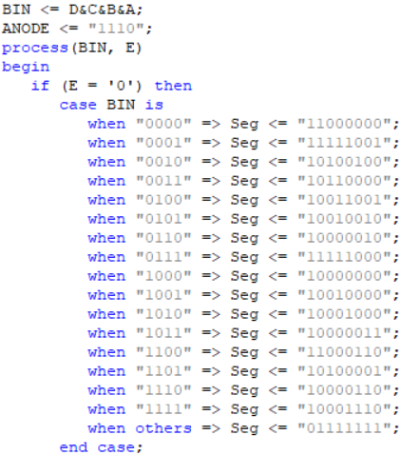

Code for display the number in the 7-segment display

Image 1.2

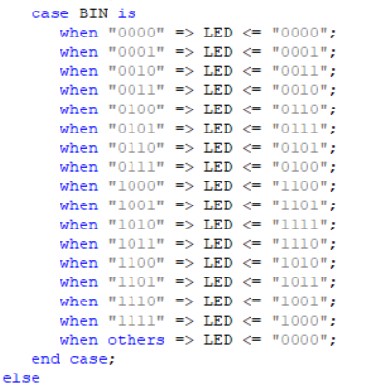

Image from code to convert from bin to grey

The following images (images 1.3 and 1.4) is for the rest of the code and is just a mirror of the code above for converting from grey to bin in case the switch is on.

Image 1.3

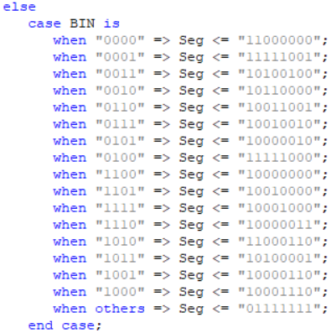

Code for display the number in the 7-segment display

Image 1.4

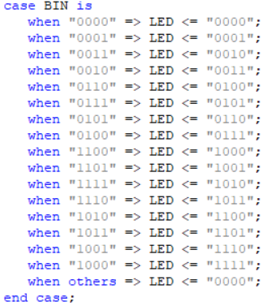

Image from code to convert from grey to bin

Results obtained:

The result was a successful decoder from binary to digital displayed in the FPGA using also the switches and 7 segment display as input and output for Grey and Bin. Also the FPGA display the code for grey or binary in the led above the switches, depending of the selection of the switch which selects if it converts from one to another.

Evidence:

Video: https://youtu.be/jypRVOaV9eY

Case 1: Case 2:

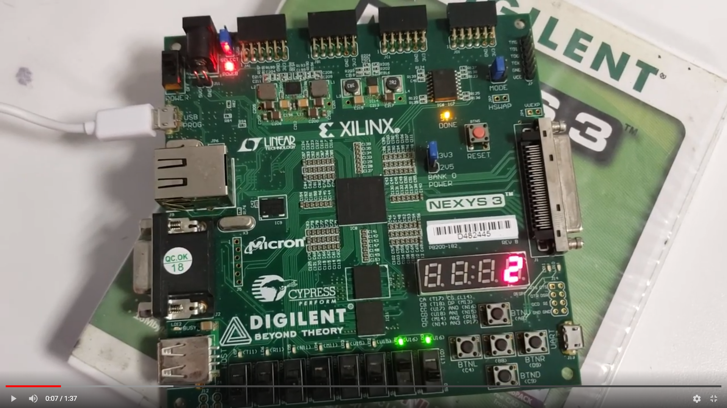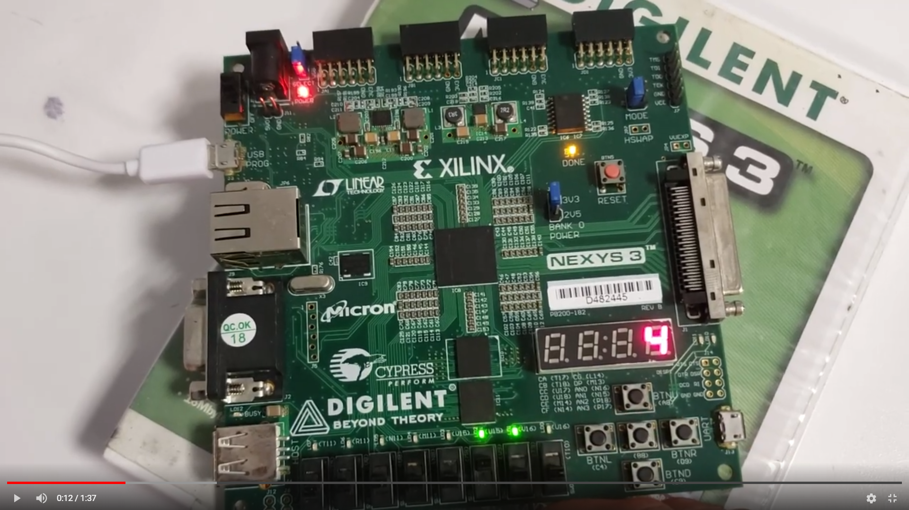

Case 3: Case 4:

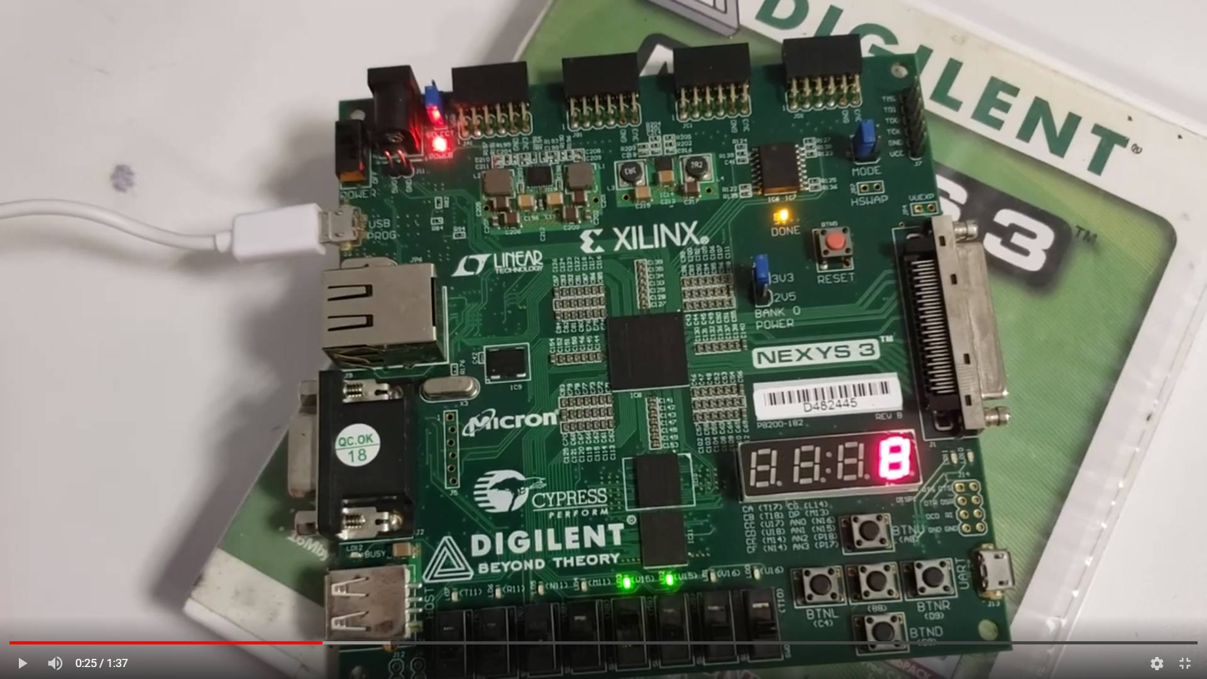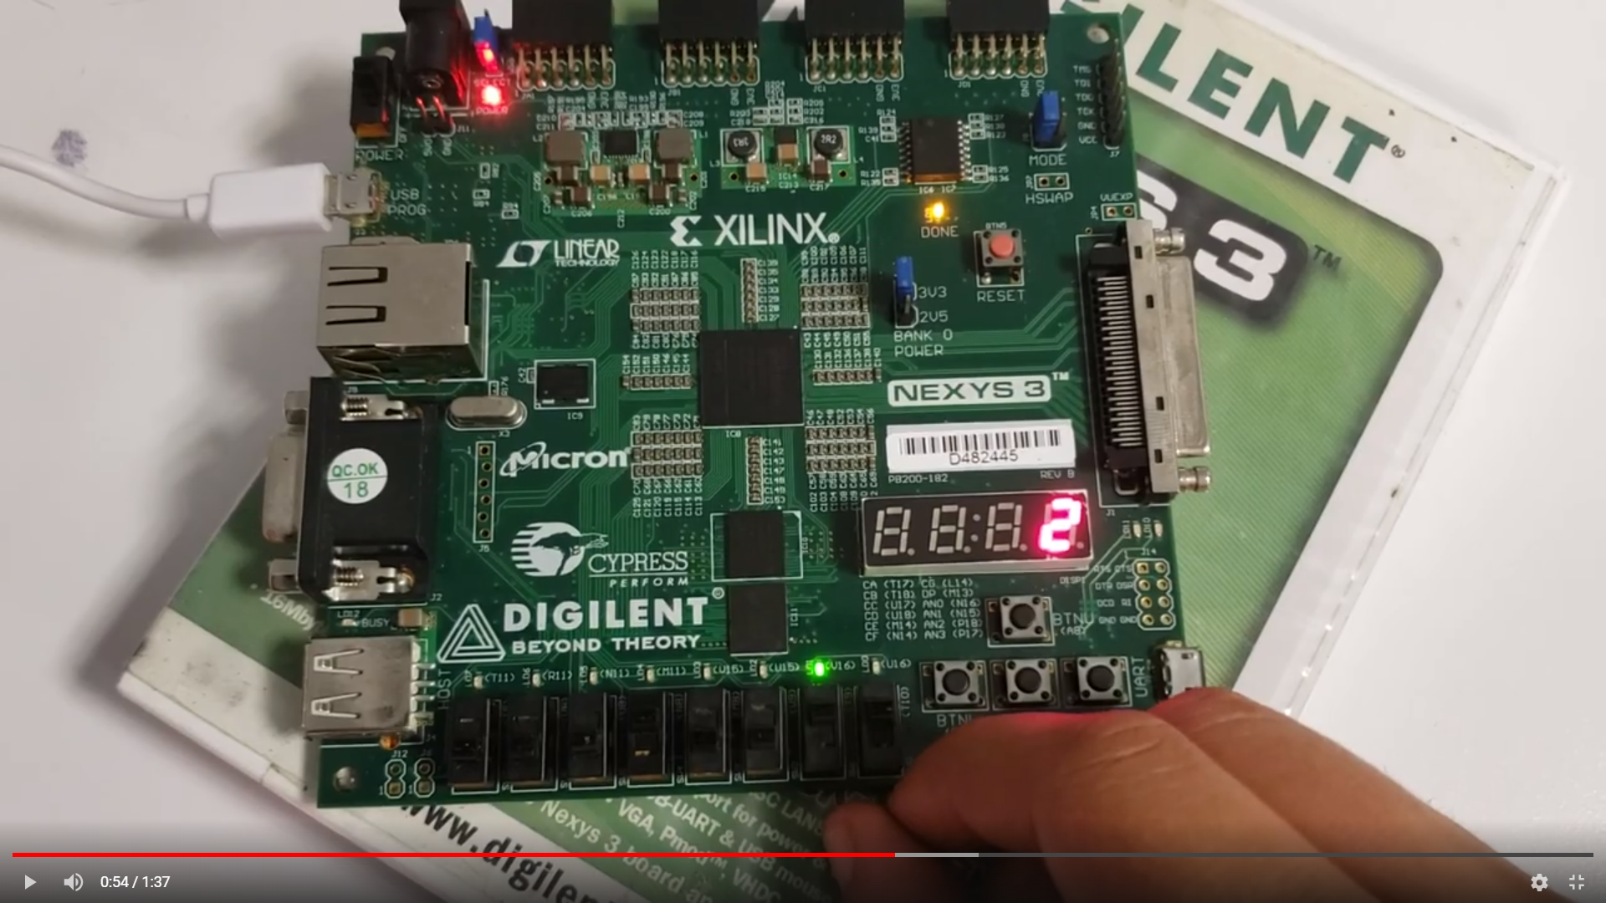

Case 5: Case 6:

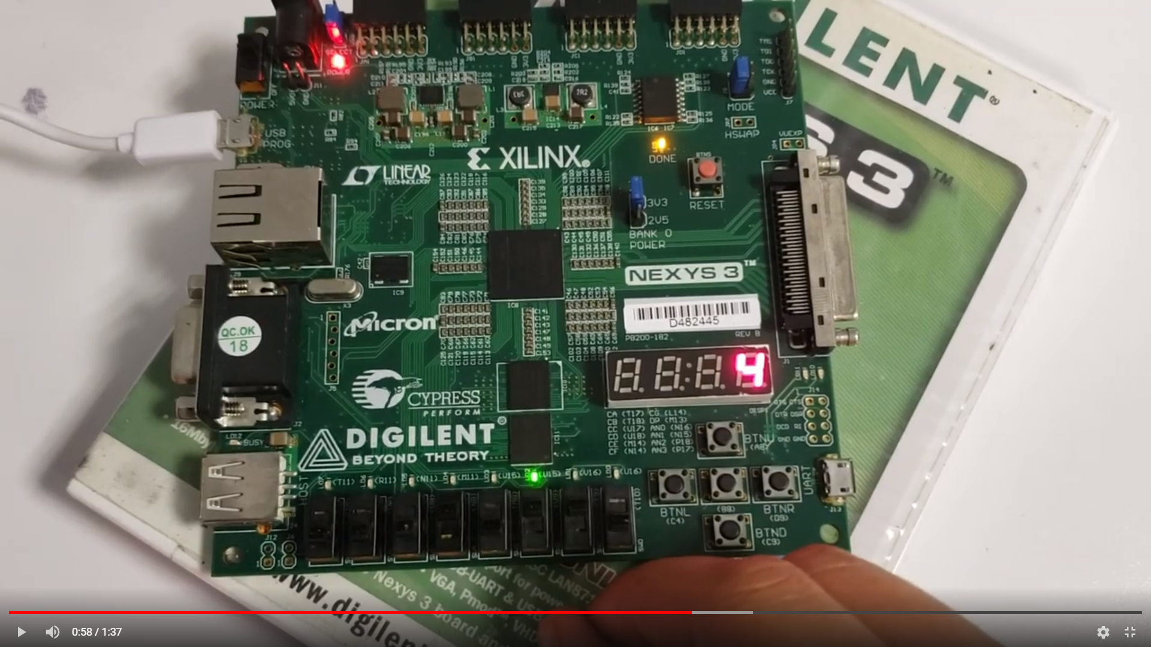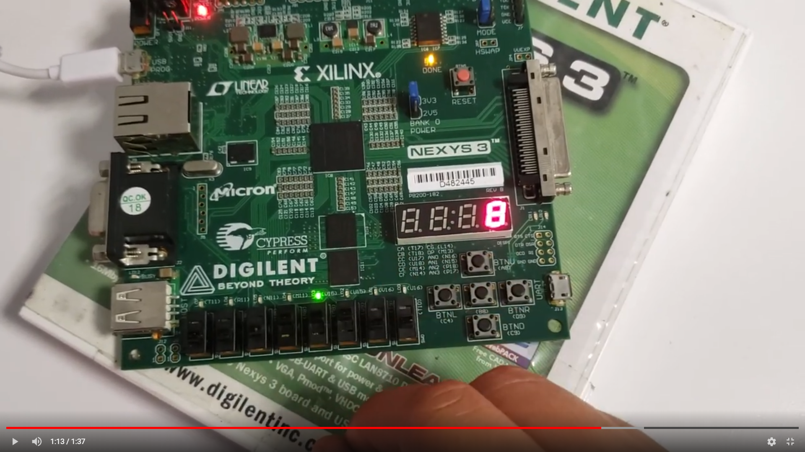

Conclusions:

The recycling of the code and using the method of truth table it is much easier and faster to create and resolve problems with the FPGA.

Problems encountered:

The first method learnt in class (when, select) didn’t work because the version of VHDL, instead I used the case method.